ATTACHMENT A - APPLICATION FORM
CALL FOR APPLICATIONS
BIOSFERA PRIZE
1ST EDITION - THE NATURE OF CULTURE
OPEN CALL FOR THE CREATION OF AN IMMERSIVE SITE-SPECIFIC VIDEO WORK
To: Fondazione Pescheria – Visual Arts Center
Corso XI Settembre 184
61121 Pesaro
fondazionepescheria@pec.it
The undersigned: _______________________________________________________________________
born in __________________________________ on ___________________residing at___________________________
ZIP_____________address__________________________________________________________No.________________
tax code (or equivalent identification) __________________________________ tel _______________
email _________________________________
REQUESTS TO BE ADMITTED TO THE OPEN CALL SELECTION FOR THE CREATION OF AN IMMERSIVE SITE-SPECIFIC VIDEO WORK:
BIOSFERA PRIZE. 1ST EDITION - THE NATURE OF CULTURE
For this purpose,
the individual is aware of the criminal penalties provided for under Article 76 of the Presidential Decree 445/2000 for any instances of falsification or false statements indicated therein, pursuant to Articles 46 and 47 of Presidential Decree No. 445/2000.
The individual therefore declares,
under their own responsibility, to meet the following requirements (to qualify for selection, all required qualifications must be met by the application deadline):
- to be an Italian citizen, a citizen of one of the member states of the European Union, or a non-EU citizen, provided they are legally residing in Italy. Foreign citizens must also enjoy civil and political rights in their country of citizenship or origin;
- to be at least eighteen years old;
- to enjoy full civil and political rights;
- to have no criminal convictions for intentional offenses and not to be subject to any preventive measures;
- to not be subject to any pending criminal proceedings;
- to hold the following educational qualification: ____________________________________________
the individual attaches:
the folder containing the required technical materials (PDF Files 1, 2, and 3) for the application (the file must be uploaded to a cloud storage platform of choice) and available for download via the following link: ____________________________________________
a photocopy of a valid identification document.
Privacy
The individual hereby declares that, in accordance with Legislative Decree No. 196/2003 and EU Regulation 679/2016, they are informed that the data provided will be processed by the Fondazione Pescheria – Centro Arti Visive exclusively for the purposes related to the competition announcement.
Intellectual property
Except for the author's moral rights, all projects, materials, and content created by the participant (referred to as Works) will be used by the Foundation free of charge and exclusively for six months from the deadline of the competition announcement. After this period, the participant may freely use the Work. The Foundation will not exploit the Work commercially during these six months.
During the exclusivity period, the participant cannot use the Work without authorization from the Foundation.
The Foundation has the right to use the content created for specific project purposes, such as reporting and documentation, including in digital format (website, photos, videos, texts).
Email address and/or certified email (PEC) where you wish to receive communications regarding the selection ____________________________________________
Landline and/or mobile phone number where you wish to receive communications regarding the selection ____________________________________________
(location and date), ____________________________________________
signature for acceptance ____________________________________________
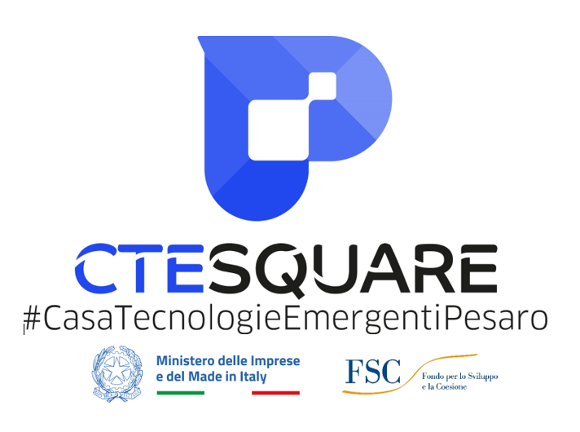



POWERED BY

